1. Create C# class Employee with the fields eno, ename, address, designation, mobile number, salary, city, pincode. Create necessary methods to read the information and display the information. The employer contains 10 employees. The employer wants to know the total salary paid to its employees. As a programmer how do you suggest a solution to his problem?

2. Create a C# class to read the book information to a library which includes booknumber, name, pages, issn number, price, year_of_publication. Use C# Properties to store the information into these variables and retrieve the information.

3. Write a C# program of jagged array which declares, initializes and traverse jagged arrays.

4. Create a class Student with the filed sno, sname, marks in three subjects. Create a method SetStudentDetails() which will read the information from the student. Create another method GetStudentDetails() which will display the information. Also, another method to compute the average mark of the student in three subject. Display the information.

5. Write a C# program which takes variable number of parameters i.e using params

6. Write a C# program to create a struct Rectangle which has two data members width and height, where we are using constructor to initialize data and method to calculate area of rectangle.

7. Write a C# program on Multicast Delegates

8. Write a C# program to create an interface Drawable which has draw() method. Its implementation is provided by two classes: Rectangle and Circle.

9. Create a Class Polygon with three variables l,b,h. Create a parameterised method to set the values to l,b,h. Create an abstract method compute().

10. Implement the following inheritance:

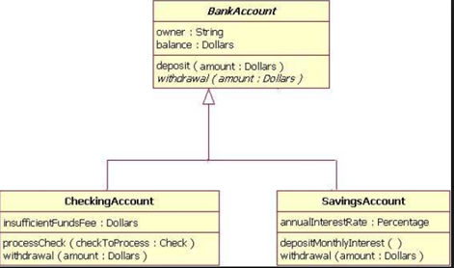

11. Create the form and validate the credentials.

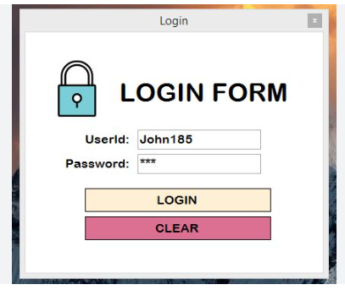

12. Create the following form and store in the database

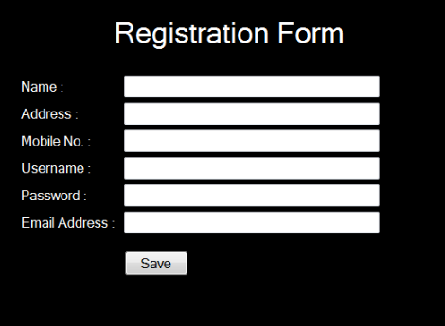

13.Create an application in to store the following data in a Registration table.  
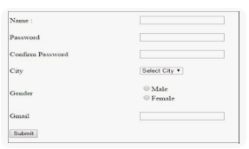

14.Create a registration page and store the collected information in a table when the user registrar.

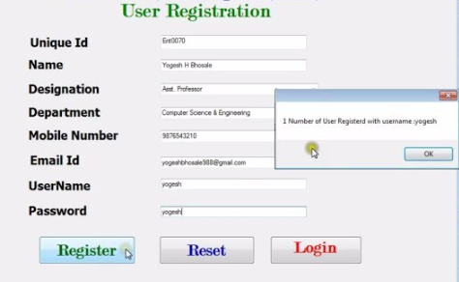

15.Create the following form and store in the student table

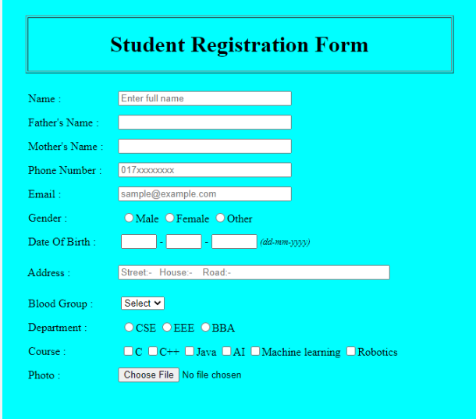

16.Create the following form and store the information

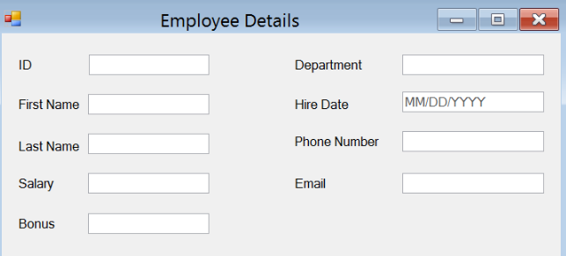

17.Create an employee registration form and when the user submits the button store in the database  
